Heaven's light is our guide
Rajshahi University of Engineering & Technology

Department of Computer Science & Engineering


Lab Assignment

Course Name : Computer Architecture Sessional
Course Code : CSE 3108

Submitted by :  Name : Md. Asad-Al-Adil  Roll no : 2103064  Section : B  Series : 21 | Submitted to:  Utsha Das  Assistant Professor  Department of Computer Science & Engineering, RUET

Set A

- 4-Bit Full Parallel Subtractor using Logisim:
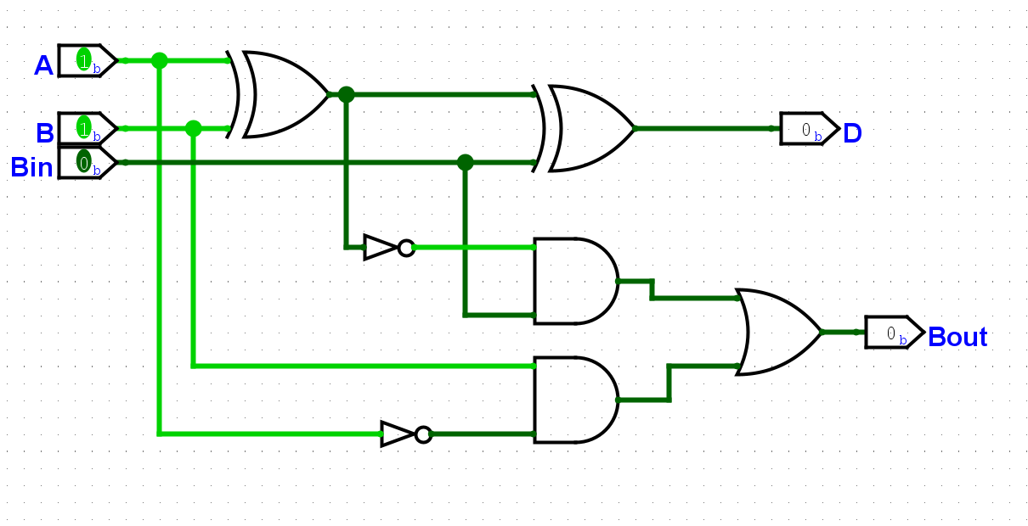
1-bit Full Subtractor
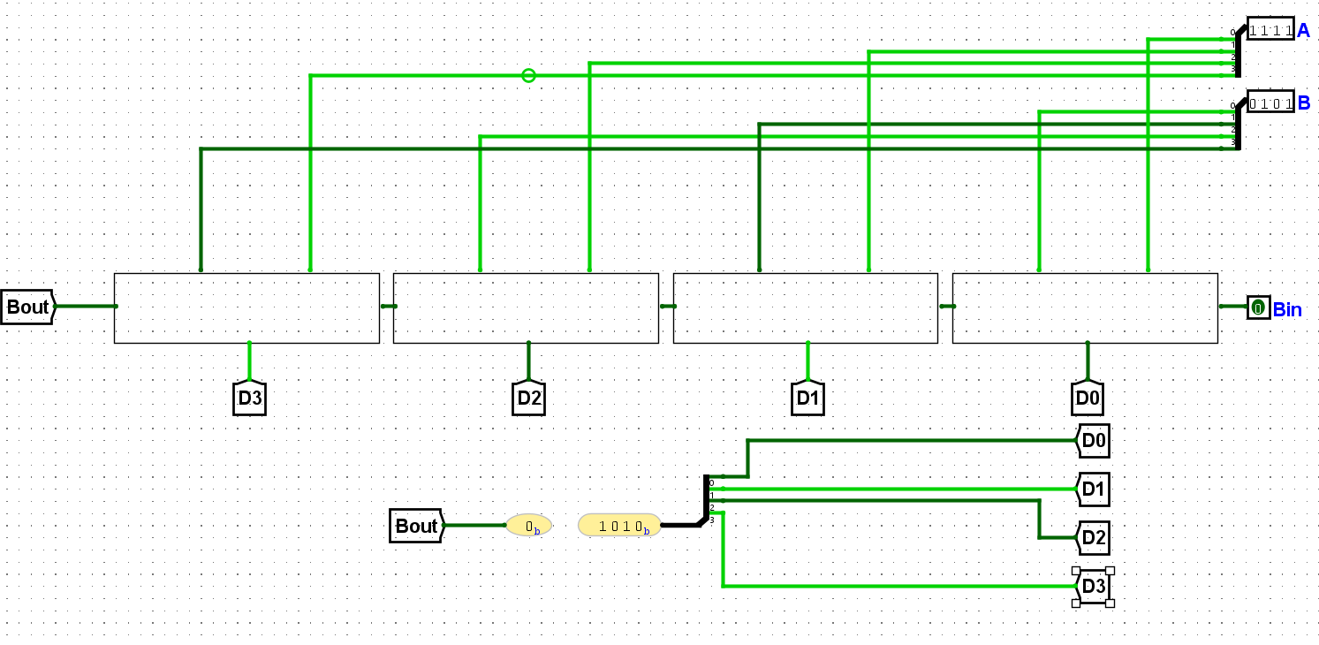

- 4-bit Down Counter using HDL programming:
register.v
module register (
input wire [3:0]d,
input wire clk,
input wire reset,
output wire [3:0]q
);

reg [3:0]r_reg;
wire [3:0]r_next;

always @(posedge clk, posedge reset)
begin
if (reset)
r_reg<=4'b0000;
else
r_reg<=r_next;
end

assign r_next=d;
assign q=r_reg;

endmodule

subone.v
module subone (
input wire [3:0]I,
output wire [3:0]O
);

assign O=I-1;

endmodule

counter.v
module counter (
input wire clk,
input wire reset,
output wire [3:0]q
);

wire [3:0]d_temp,q_temp;

register c1(d_temp,clk,reset,q_temp);
subone c2(q_temp,d_temp);

assign q=q_temp;

endmodule

cnt_tb.v
`timescale 1ns/1ps
module cnt_tb;
reg clk;
reg reset;
wire [3:0]q;

counter uut(clk,reset,q);

always begin
clk=~clk;
#10;
end

initial begin
$dumpfile("test.vcd");
$dumpvars(0,cnt_tb);

clk<=0;
reset<=1;
#20;
reset<=0;
#20;#20;#20;#20;#20;#20;#20;#20;#20;#20;#20;#20;#20;
#40;

$finish;

end

initial begin
$monitor("reset=%b clk=%b q=%b",reset,clk,q);
end

endmodule

Output:
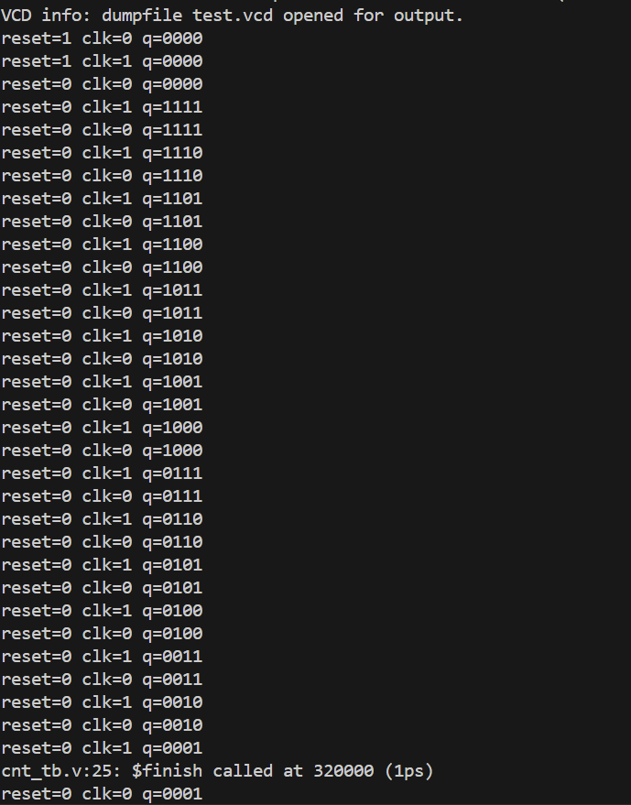

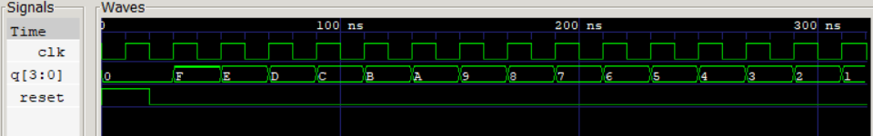
Set B

- 4-bit Arithmetic Right Shift using Logisim:

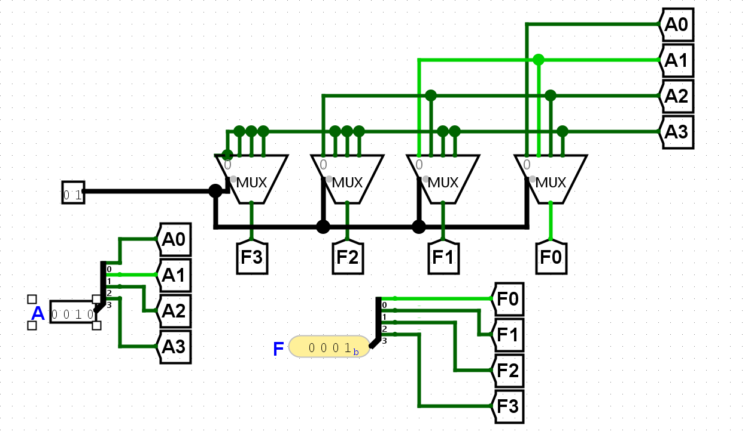

- 4-bit Full Subtractor using HDL programming
1_bit_sub.v
module sub1 (
input wire A,
input wire B,
input wire Bin,
output wire D,
output wire Bout
);

assign D=A^B^Bin;
assign Bout=Bin&(~(A^B)) || (~A)&B;

4-bit_sub.v
module Full_sub (
input wire [3:0]A,
input wire [3:0]B,
input wire Bin,
output wire [3:0]D,
output wire [3:0]Bout
);

sub1 s0(A[0],B[0],Bin,D[0],Bout[0]);
sub1 s1(A[1],B[1],Bout[0],D[1],Bout[1]);
sub1 s2(A[2],B[2],Bout[1],D[2],Bout[2]);
sub1 s3(A[3],B[3],Bout[2],D[3],Bout[3]);

endmodule

fs_tb.v
`timescale 1ns/1ps
module fs_tb;
reg [3:0]A;
reg [3:0]B;
reg Bin;
wire [3:0]Bout;
wire [3:0]D;

Full_sub uut(A,B,Bin,D,Bout);

initial begin
$dumpfile("test.vcd");
$dumpvars(0,fs_tb);
A=4'b1000;
B=4'b0011;
Bin=0;
#20;
A=4'b1111;
B=4'b0011;
#20;
A=4'b1001;
B=4'b1001;
#20;
A=4'b0111;
B=4'b1010;
#20;
#40;
end

initial begin

$monitor("A=%b, B=%b Bin=%b D=%b Bout=%b",A,B,Bin,D,Bout);
end

endmodule

Output:
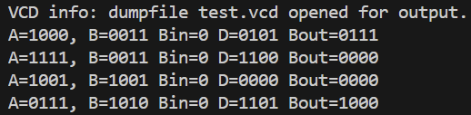

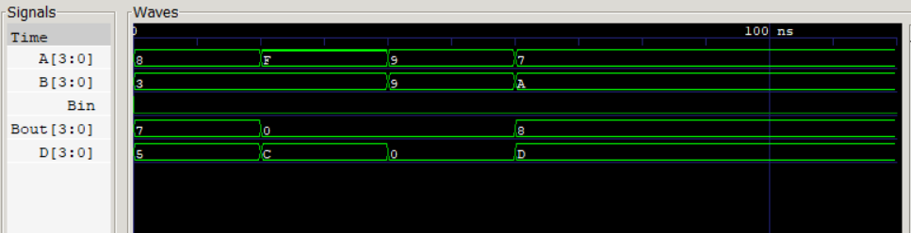

Set C

- 4-bit Right Shift using Logisim
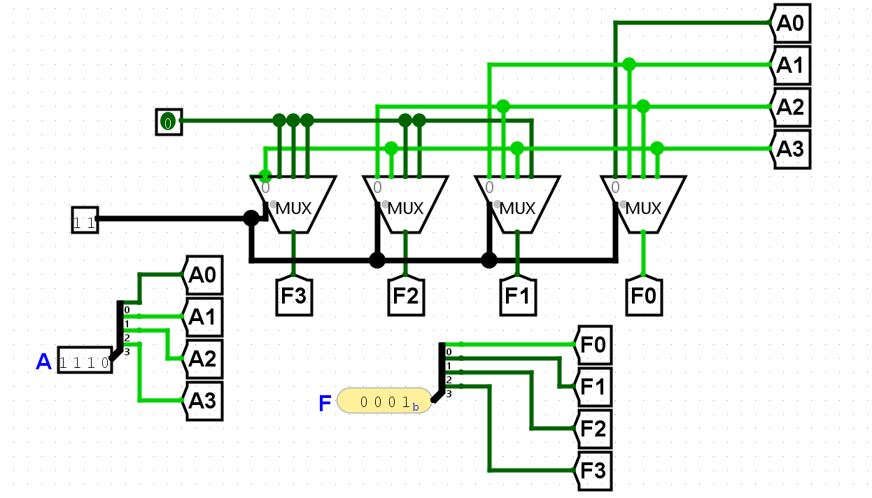

- ARM Assembly Code for 10th Fibonacci Number:
;;; Directives
PRESERVE8
THUMB
; Vector Table Mapped to Address 0 at Reset
; Linker requires __Vectors to be exported
AREA RESET, DATA, READONLY
EXPORT __Vectors

__Vectors
DCD 0x20001000
; stack pointer value when stack is empty
DCD Reset_Handler ; reset vector
ALIGN
; The program
; Linker requires Reset_Handler
AREA MYCODE, CODE, READONLY
ENTRY
EXPORT Reset_Handler
Reset_Handler
;;;;;;;;;;User Code Starts from the next
line;;;;;;;;;;;;

MOV R0,#0
MOV R1,#1
MOV R2,#2

FOR
CMP R2,#10
BEQ DONE
ADD R3,R0,R1
MOV R0,R1
MOV R1,R3
ADD R2,R2,#1
B FOR

DONE
END

Output:
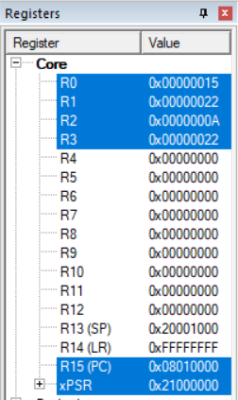
Set D

- F=(AB+CD)` using CMOS transistor in Logisim

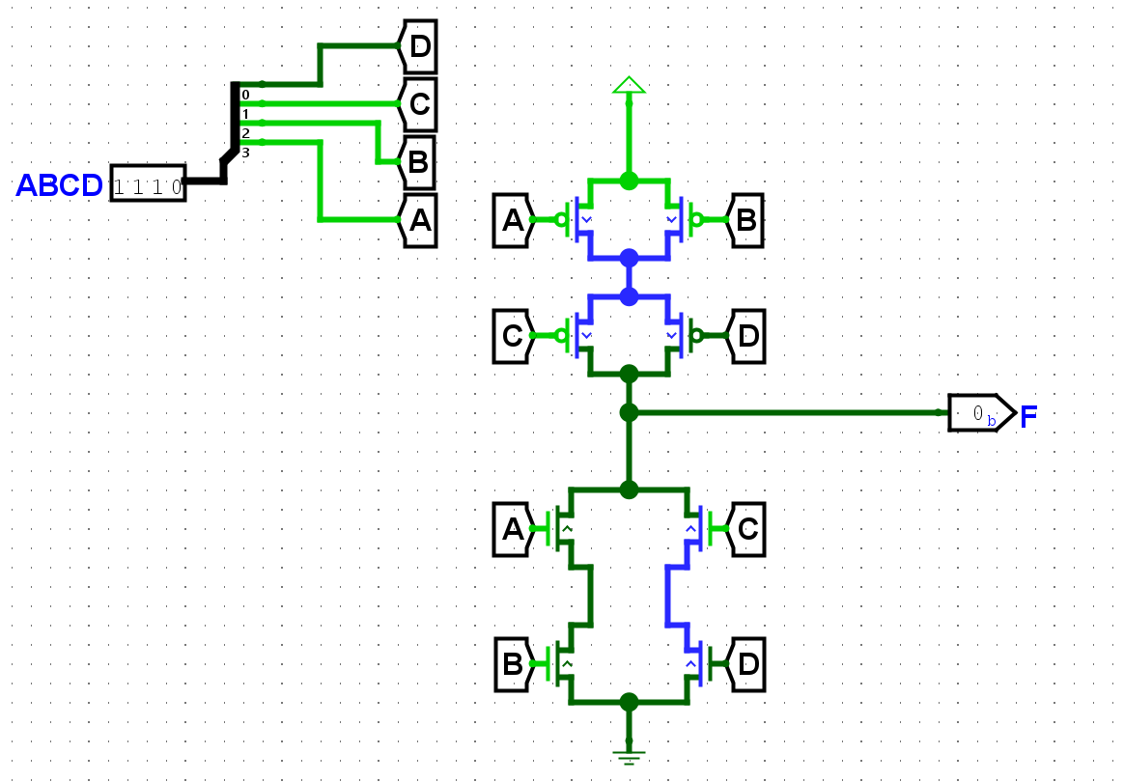

- 4 to 2 Priority Encoder using HDL programming
circuit.v
module priority_encoder (
input wire [3:0]A,
output wire [1:0]Y
);

assign Y[0]=(~A[3])&(~A[2])&(A[1]) || A[3];
assign Y[1]=(~A[3])&(A[2]) || A[3];

endmodule

tb.v
`timescale 1ns/1ps
module tb;
reg [3:0]A;
wire [1:0]Y;

priority_encoder uut(A,Y);

initial begin
$dumpfile("test.vcd");
$dumpvars(0,tb);

A=4'b0111;
#20;
A=4'b1111;
#20;
A=4'b0011;
end

initial begin
$monitor("A=%b Y=%b",A,Y);
end

endmodule

Output:
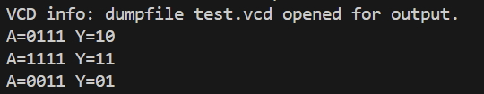

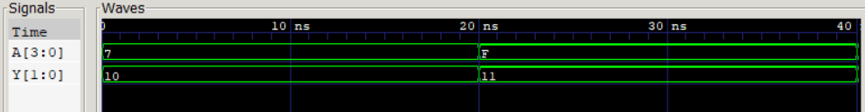

Set E

- F=(AB+CD)` using NMOS transistor in Logisim
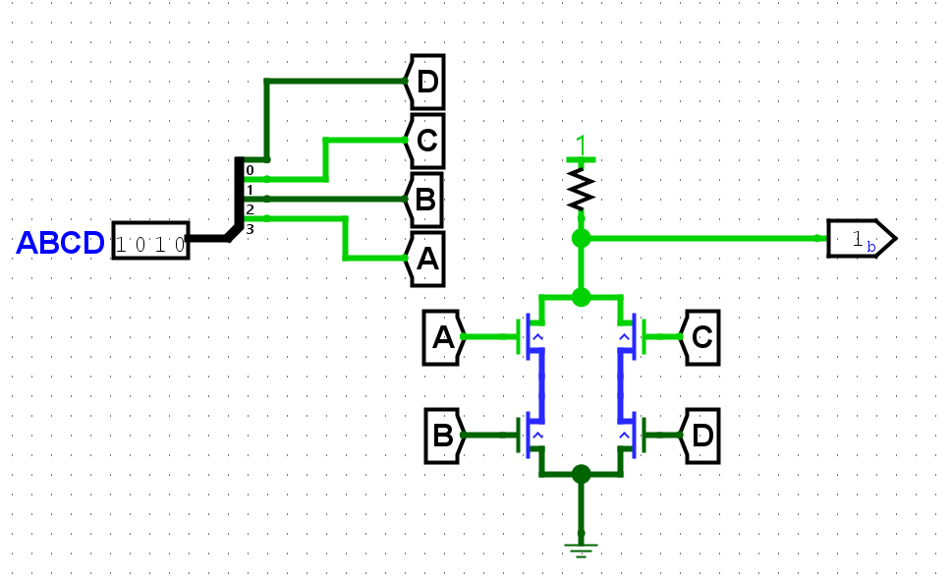

- MOD-5 Counter using synchronous design methodology
register.v
module register (
input wire [2:0]d,
input wire clk,
input wire reset,
output wire [2:0]q
);

reg [2:0]r_reg;
wire [2:0]r_next;

always @(posedge clk, posedge reset)
begin
if (reset || r_reg==3'b100)
r_reg<=3'b000;
else
r_reg<=r_next;
end

assign r_next=d;
assign q=r_reg;

endmodule

addone.v
module addone (
input wire [2:0]I,
output wire [2:0]O
);

assign O=I+1;

endmodule

counter.v
module counter (
input wire clk,
input wire reset,
output wire [3:0]q
);

wire [2:0]d_temp,q_temp;

register c1(d_temp,clk,reset,q_temp);
subone c2(q_temp,d_temp);

assign q=q_temp;

endmodule

cnt_tb.v
``timescale 1ns/1ps
module cnt_tb;
reg clk;
reg reset;
wire [2:0]q;

counter uut(clk,reset,q);

always begin
clk=~clk;
#10;
end

initial begin
$dumpfile("test.vcd");
$dumpvars(0,cnt_tb);

clk<=0;
reset<=1;
#20;
reset<=0;
#20;#20;#20;
#40;

$finish;

end

initial begin
$monitor("reset=%b clk=%b q=%b",reset,clk,q);
end

endmodule

Output:
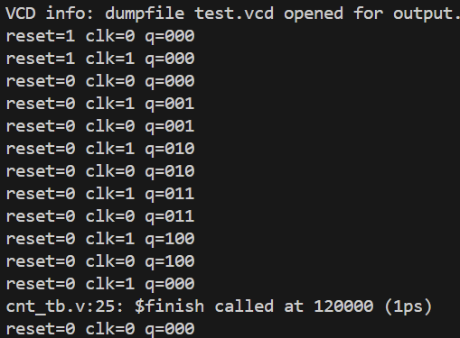

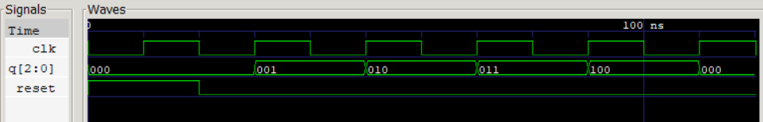

Set F

- 4-bit Left shift using Logisim
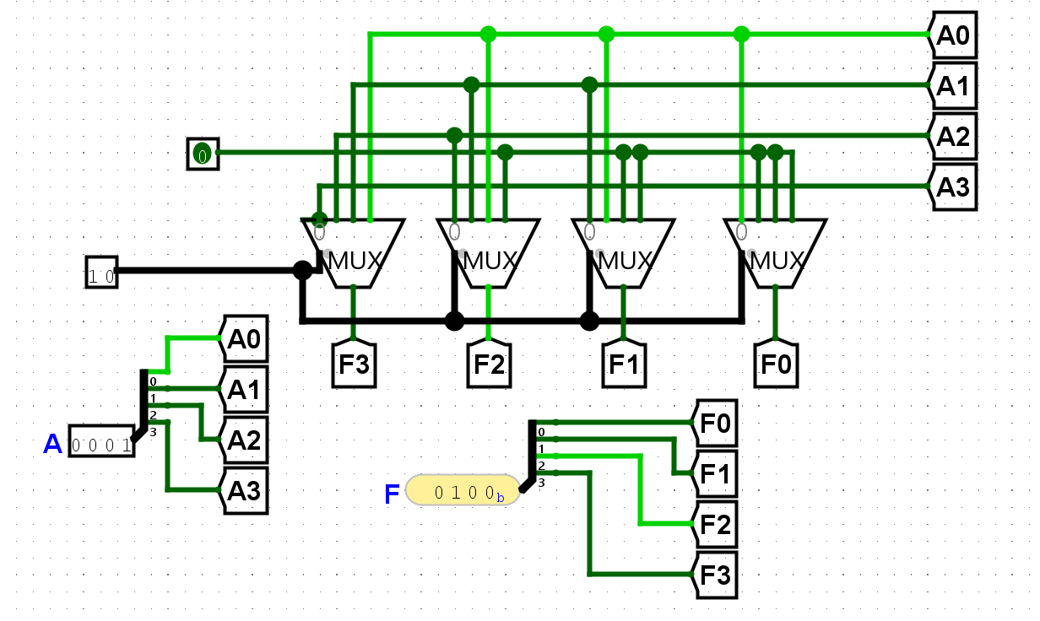

- ARM Assembly code to calculate the summation of the 1st N elements of the following series, 1+3+5+7+……(assume n=20)
;;; Directives
PRESERVE8
THUMB
; Vector Table Mapped to Address 0 at Reset
; Linker requires __Vectors to be exported
AREA RESET, DATA, READONLY
EXPORT __Vectors

__Vectors
DCD 0x20001000
; stack pointer value when stack is empty
DCD Reset_Handler ; reset vector
ALIGN
; The program
; Linker requires Reset_Handler
AREA MYCODE, CODE, READONLY
ENTRY
EXPORT Reset_Handler
Reset_Handler
;;;;;;;;;;User Code Starts from the next
line;;;;;;;;;;;;

MOV R0,#1
MOV R1,#1
MOV R2,#1
FOR
CMP R0,#20 ;N=20 assume
BEQ DONE
ADD R1,R1,#2
ADD R2,R2,R1
ADD R0,R0,#1
B FOR
DONE
END

Output:
